To copy the file of previous date in format od_12052024.txt

1. Create resource group
2. Create adls
3. Create containers
4. Create inbound and outbound folder in those containers
5. Add files to inbound
6. Create datafactory
7. Go to data factory
8. Create linked service to the adls
9. Create datasets for inbound as well as outbound folder
10. Now create the parameter for dataset 1 for file and add dynamic content in value and add that parmeter
11. Now add those datasets to copy activity in source and sink
12. Now add dynamic content in values for file in source
13. Now go to string function ->concat function->format function->add days->utnow->
14. 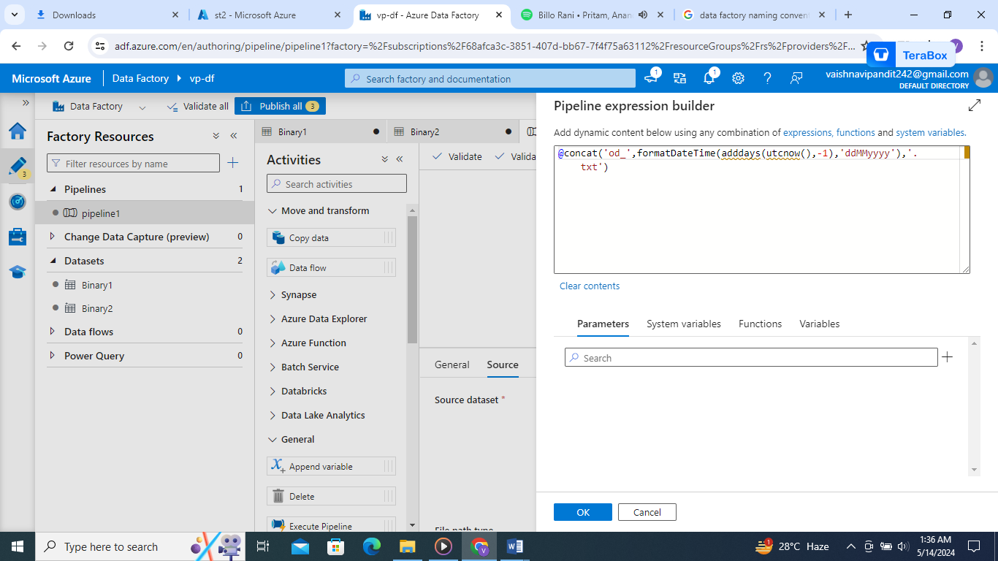
15. Debug the pipeline